Design Patterns Final Review

1. Composite : [Click_Here](https://medium.com/@akshatsharma0610/composite-design-pattern-b1ebd0756aa9) + object inside an object.

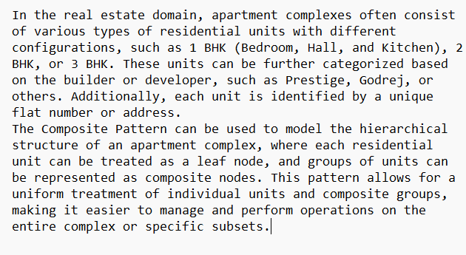

1. Flyweight : [Click_Here](https://medium.com/@robinsrivastava737/flyweight-design-pattern-0d92fde6e6c0)

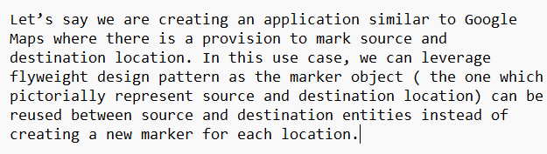

1. Command : [click_here](https://medium.com/swlh/command-pattern-what-it-is-and-how-to-use-it-7ccbc810266d)

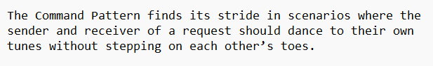

1. Visitor : [Click_Here](https://medium.com/@priya104/the-visitor-pattern-34177d7252a6)